Rex

Rex Proposal #1

**A Decentralized Global Multiple Listing Service and Real Estate Smart Contract Application**

May 24, 2016

Prepared by Rex Prepared for The DAO

**Disclaimer**

This proposal is prepared for prospective DAO Token Holders. The purpose of this proposal is to outline Rex’s mission to decentralize segments of the real estate industry, starting with the multiple listing service then progressing to real estate smart contracts.

Rex: We are referring to the platform, Rex

REX: We are referring to the token, REX

To submit comments please contact:

[support@rexmls.com](mailto:Support@rexmls.com)

[www.rexmls.com](http://www.rexmls.com)

For additional details, please read the Rex white paper.

**About Us**

Rex is pioneering the real estate industry using the Ethereum Virtual Machine. Rex’s goal is to democratize real estate information and establish a new process to transact real estate. Using Ethereum and IPFS/Swarm, Rex will provide a cheap, reliable means for listing and transacting real estate worldwide.

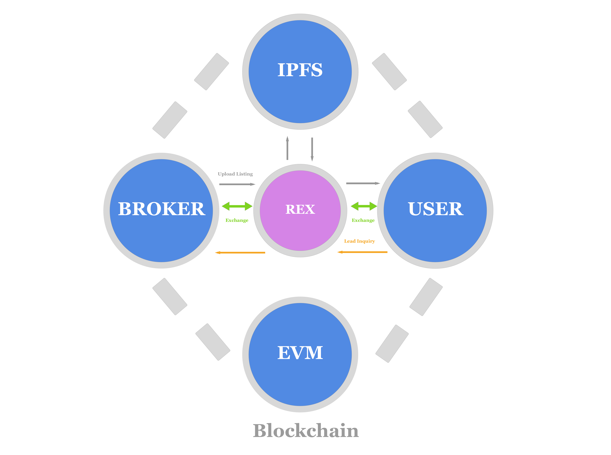

**Team**

Stephen King

Stephen is an entrepreneur with a focus in commercial real estate and blockchain technology. Since 2013, Stephen has lead King Realty Group in Princeton, New Jersey and participated in over forty-five million dollars in real estate transactions. Stephen is the founder of Princeton Ethereum Meetup.

Russell McLernon

Russell is the technology strategist. He brings over 15 years of experience in enterprise software development and over 7 years in blockchain related development and projects. Although acutely technical, he has an innate ability to quickly decipher user needs. There's no software development or integration challenge he can't handle.

**Executive Summary**

Traditionally, obtaining reliable property information and conducting efficient real estate transactions has been difficult. Today, with the advances in technology, data has become much easier to ascertain. However, the data has become controlled, manipulated, and governed by centralized organizations resulting in exorbitant transaction and listing fees. Additionally, the transaction process can take 6-12 months and cost tens of thousands of dollars. With recent advances in data distribution and blockchain technology, Rex recognizes the opportunity to streamline the transaction process and provide an inexpensive means to disseminate real estate information. The result will be low transaction costs and a means for users to virtually obtain property information for free.

**Detailed Summary**

Rex will roll out in two phases: Phase I (a decentralized, global Multiple Listing Service “MLS”) and Phase II (the implementation of smart contracts for real estate related transactions).

Background for two phase release:

The protocols being developed by the Ethereum Foundation, IPFS, and Swarm are new technologies. Like any new technology, it will take time for the infrastructure and mainstream audience to develop. We see the progression much like that of Netflix:

Reed Hastings built Netflix with the idea of streamlining the way consumers view content. Using Hastings’ platform, consumers could rent a video online to avoid the inconveniences associated with traditional retail rentals (time, travel, and late fees). The value of Netflix was created through the maturity of digital technology and the comfort of paying/obtaining content via the internet. Netflix capitalized on both opportunities, but remained patient through the transition period. Today, Netflix is becoming one of the largest content providers in the world.

Rex envisions that blockchain technology will take a similar path. The technology requires time to evolve and the consumer requires trust in the system.

**Phase I**

In Phase I, Rex will begin to tell the story of each property. Rex is building a decentralized, global multiple listing service. Users can virtually view/list properties for free, while becoming comfortable with cryptographic transactions. The accumulation of data/public transactions will begin to prepare the platform for Phase II.

**Phase II**

In Phase II Rex will tell the entire story of each property. Over time, Rex will provide a comprehensible history of each individual parcel. Rex will implement the use of smart contracts through escrow, title, and identity services, while simultaneously compiling the data in an easy to read, traceable format.

**Addressable Market**

In the United States, the commercial real estate industry is valued at 15 trillion and the residential industry at approximately 24 trillion. Unlike traditional MLS’ that charge excessive annual subscription fees and title agencies that drain most transactions, Rex will operate autonomously and fund itself through its internal exchange. The result will be a decentralized platform where users can virtually list/view real estate data for free. Rex will then implement the use of smart contracts capitalizing on the full potential of the addressable market.

**REXDEX (Rex’s internal decentralized exchange. Please see the Rex white paper for additional details)**

Initial Coin Distribution

Rex will have an initial coin supply of zero. In order to facilitate a fair means of distribution, there will be four ways users can obtain REX.

1. Place buy orders on the REXDEX, hope to win the Liquidity Injection Distribution rewards (L.I.D.) (1), or have someone take your offer
2. Participate in the REX crowdfund
3. Claim 'The DAO' reward points for REX
4. Start submitting listings as a registered broker and receive listing rewards (for a limited time)
5. Liquidity injection distribution: The process we invented in which the top 10 bidders on the RexDex (price * duration) are rewarded every six hours with up to 35,000 newly issued REX.

**Rewards**

Initially, the RexToken contract will allow the creators to issue rewards based on evidence of listings. Registered listees will be eligible for a 100 REX reward for each valid listing they list in the system with a bonus reward of 500 REX if it is listed exclusively and that is proven after a month or two. The reward will issued 30 – 60 days following the post.

Rex will provide an auto reward for "verified" listees with a one-month payment delay. If they are found to be listing fake/abusive listings, the verified listee profile will be flagged and their pending reward disqualified.

By doing automated rewards Rex can keep issuing rewards up to 1,000,000 listings a year. At which point, Rex would be issuing 100,000,000 REX per year or 10% of the total (1,000,000 * 100). At this point, the reward system would be adjusted in order to scale demand.

Eventually the reward system will be scaled down to zero.

**Investment Rewards**

Rex will escrow 5,000,000 REX into a smart contract that will be released to DAO Token Holders following the beta release of the platform.

**Fund Raising Goal**

Initially, we will hold two major crowdfunding campaigns. The first (and the purpose of this proposal) is to take the prototype to beta. The development team’s outline is as follows:

* 1. Bootstrap development, create a functional product and a detailed white paper and begin promotion at real estate/block chain conferences (completed)
  2. Fundraising Campaign #1: Create a functional beta for mainstream testing i.e. the real estate community. We estimate a six-nine month time frame with a budget of $350,000. A large focus will be on the user experience in order to attract a mainstream audience.
  3. Fund Raising Campaign #2: Following the release/testing of beta, Rex will raise a second fundraising Campaign. Campaign #2 will be a larger round to fund the full development of the Rex platform.

**Timeline**

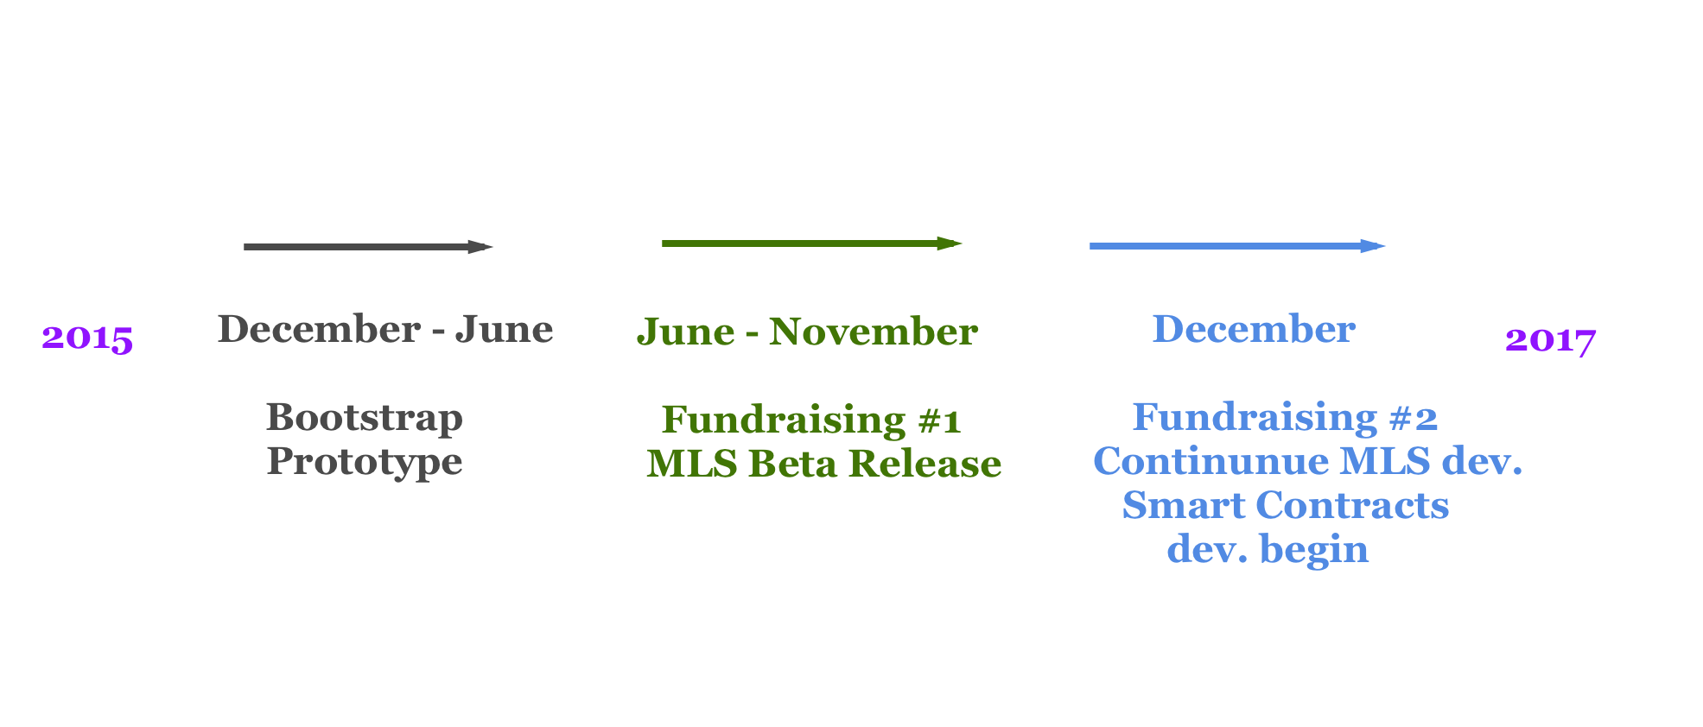

Month 1: Continue development/add to the core development team

Month 2 - 4: Development, design, legal

Month 4 - 6: Marketing begins

Month 6-7: Beta release

Month 8-9: Campaign #2.

**Use of Funds**

1. Development/Design
2. Legal
3. Marketing
4. Travel (promotion)

**Sources**

1. <https://www.census.gov/construction/nrs/pdf/newressales.pdf>
2. <http://www.forbes.com/sites/groupthink/2014/12/16/why-commercial-real-estate-is-ripe-for-disruption-in-2015/#4f858f67529e>
3. <https://www.census.gov/const/uspriceann.pdf>